Press release

GC 100th anniversary

GC unveils dedicated brand to mark its 100th anniversary
On 11 February 2021 GC celebrates the 100th anniversary since it was founded in Japan in 1921. In honour of this significant milestone, GC has prepared a number of initiatives to commemorate and celebrate, both internally and externally, throughout the year.
As part of this, Dr. Kiyotaka Nakao, GC Corporation President and CEO, has officially launched a specially designed centenary brand and slogan to be used during the anniversary year across all GC companies worldwide.
The custom brand design originates from a competition that GC held for all its associates (employees) to create a symbol that represents the company vision and tradition of excellence in dentistry. One of the organisation’s guiding principles is that of Nakama; which is the united spirit of cooperation among all associates of working towards a shared goal. The chosen centennial symbol therefore truly represents the company values and embodies its unity across all job titles and continents.
The brand is an adaptation of the ‘Smile for the World’ symbol that GC has used since 2017 to represent the company’s commitment to improving the quality of health of the world. The new graphic features the number 100 cleverly incorporated into the design and is paired with the slogan: “100 years of Quality in Dental”.
The slogan reflects GC’s commitment to “make further contribution to improving the quality of the dental world” as a message. It is also in alignment with GC’s naming of the 21st century as the “Century of Health,” and its striving to be the world’s No. 1 manufacturer of dental care products and to support the vitality and well-being of people all over the world.
As a privately-owned, global company, GC enters its 100th year with renewed commitment to its ideals as a workforce and a legacy that honours its founders. The new brand captures this very essence, and will take the company far beyond its 100th anniversary.

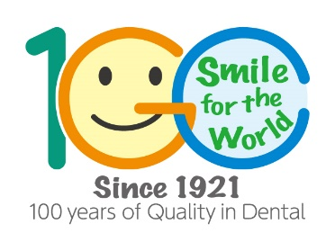

For more information, please visit:
GC Europe N.V.
Interleuvenlaan 33
3001 Leuven
Tel +32.16.74.10.00
Fax +32.16.74.11.99
www.gceurope.com
info.gce@gc.dental

