Foundation Nakao for Worldwide Oral Health
1st Term Activities & 2nd Term Recruitment of Foundation Nakao Grant Application

Foundation Nakao for Worldwide Oral Health was established on September 2018 in Lucerne, Switzerland to further contribute to the global dental community.
The Foundation believes that improving QOL is indispensable for realizing a true healthy and long-lived society in the era of 100 years of life, and that further improvement of Oral Health is the mission required for the dental community in the future. Last year, we recruited application for Foundation Nakao Grant to support research globally.
This spring, the 1st Management Board and Foundation Board meeting decided to provide grant support (50,000 CHF per case) to 6 university research institutes around the World, which was selected out of the 40 applications.
The 1st Foundation Nakao Grant Winners are as the below.
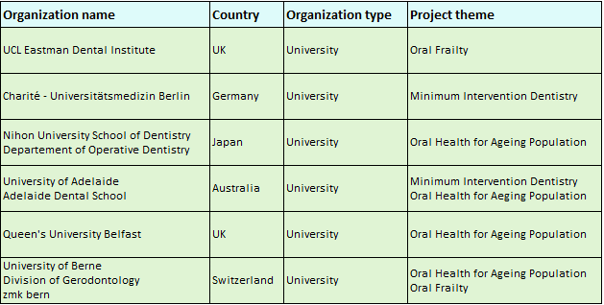
Also, other than this 6 universities, Foundation is supporting two research projects as below.
Project name | Chair | Brief description
How to support dentist in selecting appropriate restorative materials? | Prof. Reinhard Hickel | Development of decision tree for dentists to support the decision-making process for choosing ideal material to replace dental amalgam.
International Society for Minimum Intervention Dentistry (MIS) | Prof. Elmar Reich | Main aim of the society is to support research and education, promote oral health to save teeth and improve oral health, and influence international health policy.

The recruitment for the 2nd Foundation Grant application was released on September 28, 2020 and the application deadline is December 11, 2020. FY 2020 Foundation Grant Winners will be decided at the 2nd Management Board and Foundation Board Meeting next spring.
We look forward to seeing many applications for Foundation Nakao Grant from all regions.
Please refer to the Foundation's website for information on Foundation activities and Foundation Nakao Grant application.

