Press release

EQUIA Forte restorative system

EQUIA® Forte: Glass Hybrid technology strong and reliable in multiple indications

Drawing on nearly a century of experience in creating dental materials, GC has developed a new class of long-term restorative materials called Glass Hybrids.

EQUIA Forte restorative system was built on the groundbreaking success of its predecessor, EQUIA, and combines a filling component with a protective composite coating while additionally benefiting from a newly developed glass hybrid technology. The resulting restorative offers further improved performance with a unique gloss and high wear resistance, providing the ideal solution for a wide range of indications in patients of any age.
Strong and resistant, this innovative system is a reliable material for long-term class I restorations and non-stress-bearing class II restorations, as well as load-bearing class II restorations if the isthmus occupies less than half of the intercuspal distance. The support for use in load-bearing restorations is being documented in a growing number of scientific studies. A unique multicenter trial (Miletic et al)² is demonstrating that EQUIA Forte performs the same as composite restorations, as recently published in its interim results (reference material: Tetric EvoCeram®, Ivoclar Vivadent).
Remarkable features such as moisture tolerance, adhesion to tooth structure, and fast bulk placement render EQUIA Forte particularly suitable for special population groups. Small children, geriatric patients, and special care individuals routinely demand uncomplicated restorative treatment. In such situations, dentists can benefit from the patient-friendly, quick application procedure with low technique-sensitivity that EQUIA Forte provides.
Following the minimally invasive restorative approach, the glass hybrid system allows placement without the need for extended tooth preparation by drill, therefore enabling its use for smaller restorations with reduced aerosol production in many clinical situations.

Glass hybrids like EQUIA Forte and its successor EQUIA Forte™ HT (with increased aesthetics and strength) offer easy, quick, and strong long-term restorative options to the dentist while still being cost effective for patients.

For more information, please visit: https://europe.gc.dental/en-GB/products/equiaforte

GC Europe N.V.
Interleuvenlaan 33
3001 Leuven
Fon +32.16.74.10.00
Fax +32.16.74.11.99
https://europe.gc.dental
info.gce@gc.dental

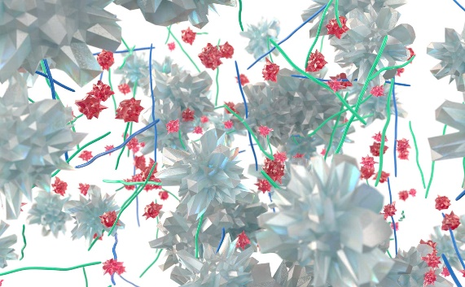
Glass Hybrid technology use two types of glass and high molecular weight poly acrylic acid powder. The innovative highly reactive FAS fillers (red) improve the crosslinking of polyacrylic acid, to increase the physical properties.

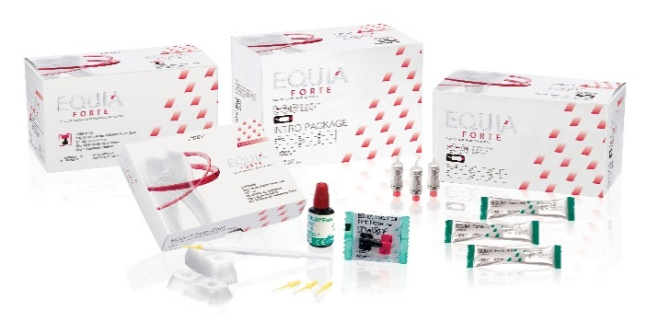

GC EQUIA Forte product line

For more information and references, please visit https://europe.gc.dental/sites/europe.gc.dental/files/products/downloads/equiaforte/reference/REF_Scientific_Sheet_EQUIA_family.pdf ² Miletic et al. Clinical Performance of a Glass-Hybrid System Compared with a Resin Composite in the Posterior Region: Results of a 2-year Multicenter Study. J Adhes Dent 22 (2020), No. 3(29.05.2020). doi:10.3290/j.jad.a44547.

