Press Release

1st European Essentia Academic Excellence Contest

Students prove their aesthetic expertise with the Essentia shade system

The suspense is finally over for entrants in the first European Essentia Academic Excellence Contest.

Leuven, October 2017 – International jurors had a difficult task choosing the best from an outstanding selection of clinical cases entered in the first European Essentia Academic Excellence Contest.

Winners from national contests in 11 European countries presented their cases to the international jury on the first day of the two-day event in Leuven, Belgium, On day two, Dr Javier Tapia and Dr Simone Moretto presented an exclusive hands-on master class on the Essentia layering technique to all participating students at the GC Europe Training Center. The event ended with a tour of the city, followed by a special dinner.
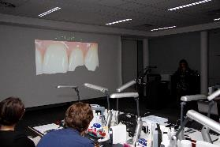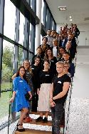
Left: The participants had 10 minutes each to present their cases. Right: The contest participants at the GC Europe Training Center.

And the winners are…
The quality of the cases was consistently high, prompting the jury to say how impressed they were by the dedication and creative talent this new generation of dentists showed in their presentations. After long deliberation amid palpable tension, the jury finally reached their decision:
- 1st European Prize Winner: Miriam Alonso Fuente, Spain
- 2nd European Prize Winner: Louise Lietaer, Belgium
- 3rd European Prize Winner: Manon Nerzic, France
- Facebook Public Prize Winner: Yusuf Kör, Turkey
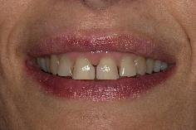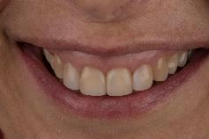
Before and after pictures of the winning entry. Documented steps of all participants’ cases can be found on the Facebook page ‘Essentia from GC’.

GC Europe and participating entities would like to congratulate all participants for the quality of their work. It was a pleasure to host them in Leuven and we are sure they all had an unforgettable experience.

Essentia Academic Excellence Contest
The Essentia concept is the perfect tool to initiate students in the art of shade selection in an intuitive way, led by the natural aging and structure of the teeth. Through organizing contests like this, GC aims to encourage students to develop their skills, and provide a forum for them to demonstrate those skills.

